Session 5 Living in the Spirit

Good evening everyone! Welcome to the final session in this year’s Lent course – before we gather for our Maundy Thursday service.

So, if we have explored the scope and work of the Holy Spirit. Then moved to looking at the role of the Holy Spirit in prayer. If we then have explored the beautiful/scandalous honesty, integrity and freedom of lament, before moving into an exploration of practical models (and mechanisms) of prayer, (especially through the Examen) – tonight I’m going to seek to tie all of this together – by looking at*‘So, going forward, how do we live this?’ How do we live - not with a million more things to do, made to feel ‘more guilty’, when we don’t find time to do the prayer that the Vicar has suggested! Going forward, how do we live this - really! How do allow the Holy Spirit (the Spirit of Christ) to influence and to guide, to nourish and transform ALL of our lives (which is simply what it truly means to be a Christian)?

Remember, being a Christian isn’t simply about say ‘yes, we believe in Jesus.’ Yes, that’s essential – but that would be like describing a race as simply when the starters pistol went off – essential – but it’s far from the whole story! Living this is the whole story!

So, first a question? *What is holier; prayer or serving others? Are you, am I, closer to God when we’re on our knees in prayer - or when you or I are’ taking the kids to school’, or ‘cleaning the kitchen’ or ‘puzzling over a spread-sheet at work’? In which context am I closer to, more in tune with, God? What do you think?

You see, traditionally we’ve always thought that the answer was obvious – it was when I was on my knees in prayer, obviously! But if you’ve been following this course, now you know that this just isn’t true, as it’s not what the Bible says at all.

Remember the* ‘Self in God’ model? You see, in that model, it’s clear that, once we turn to Christ, (just as Jesus promised), we all receive the gift of God, the Holy Spirit within us. The Holy Spirit is then at work within us all the time! And it is the Holy Spirit, who takes the initiative in drawing us towards good and towards God.

All of which means that, unlike the ‘self-outside God’ model, for us, the distinction between ‘Sacred and secular’ is now gone. We can’t think like that anymore. We can’t think that, outside of ‘a time of prayer’ we can sneak off behind God’s back and do whatever we want! For prayer and service are simply two equally important dimensions of our ‘one life’.

So, we might define*‘formal prayer’ as the time that we formally withdraw from activity to express our relationship with the Lord. Whilst ‘Service’ is simply all of the activities that we perform outside of our prayer time to fulfil God’s will in our life; which included our daily work as well as all other activities done in tune with the Holy Spirit.

So, don’t you see? *They are the same – or rather they are two intrinsically linked, interconnected parts of our one same life.

And they are equally important - because one supports and fulfils the other – because both in prayer and service we discover the very presence of God, through the same Holy Spirit.

Now, *formal prayer supporting service is pretty clear – and we see how prayer supported and enable service all the time in the life of Jesus. The gospels point out that Jesus spend many periods in extended prayer at key moments of his ministry; before the beginning of his public ministry; before his first major sermon (the sermon on the mount), before choosing the twelve disciples; before leaving Galilee and beginning his fateful journey to Jerusalem; and finally, on that night after the last supper, in the garden of Gethsemane, before his arrest and suffering. It is clear that his prayer seemed to give him both self-understanding, vision to know what his Father wanted of him - and the added strength that he needed to do it. All of which, I am arguing, that the Holy Spirit wants to do for us too – especially as we take time to notice, using tools like the Examen.

However, not only does formal Prayer support Service – but I want to argue that service (the ‘everything else’ that we do) supports formal prayer. For service is where almost all of the action happens! *Service is the time when the Holy Spirit, within the Christian, not only accompanies us, but apprentices us, equips us, inspires us, empowers us and accomplishes, through us, what God wants to achieve on this earth!

So we, my friends, have one whole life, with the same God throughout it! Isn’t that amazing! Equipped, fulfilled, enabled, empowered by Holy Spirit to be God revealers in the world!

To which I say – ‘do you think that maybe God is expecting too much of us?’ I mean, isn’t the ‘self-in-God’ model just being a bit too optimistic? I mean, I know me – and there’s hardly saintliness appearing out of every pore! I still have my struggles, as the Apostle Paul had his struggles*:

***15****I do not understand what I do. For what I want to do I do not do, but what I hate I do.****16****And if I do what I do not want to do, I agree that the law is good.****17****As it is, it is no longer I myself who do it, but it is sin living in me.****18****For I know that good itself does not dwell in me, that is, in my sinful nature. For I have the desire to do what is good, but I cannot carry it out.****19****For I do not do the good I want to do, but the evil I do not want to do—this I keep on doing.****20****Now if I do what I do not want to do, it is no longer I who do it, but it is sin living in me that does it.*

***24****What a wretched man I am! Who will rescue me from this body that is subject to death?****25****Thanks be to God, who delivers me through Jesus Christ our Lord! (Romans 7:15-20,24-25)*

And the last line is key to what is going on here! Paul was ‘working progress’ - and so are you and I! But the Holy Spirit IS at work in us. Already producing fruit – the Love, Joy, Peace, Patience, Kindness, Goodness, Faithfulness, Gentleness, Self-control of Galatians 5. I see it in you! I have experienced it here, for myself, from you!

But the truth is that, the living in tune, keeping in step, with the Holy Spirit is always a choice. We’re not robots, for God loves us, and an essential feature of love, is always that it gives freedom of choice.

So, it seems to me that no matter the power of the Holy Spirit, we too must play our part too, if we’re going to see, if we’re going to experience the intimacy with God (with God who loves us best) that we all long for, and that God longs to give us!

So, what does that mean? Do you want us to become dreadfully religious Andrew? Prayers at every hour day and night? To eat fish on Fridays and not to wear make-up on a Tuesday? Well, no! All that I want to do tonight, is to encourage us all to live a life that is shaped in such a way that will help us to deliberately and intentionally notice God. *And it’s going to take all of us: our body, our mind and our spirit.

So, when it comes to living this, going forward, let’s start with our bodies. And let me be straight here – I’m not about to give you more rules. I just want to ask – ‘When it comes to your body, what rhythms of life do you think are necessary, in your daily life, to keep your *body responsive to the direction of the Holy Spirit, in energetically doing the Father’s will?’

* How might some exercise help? Might that impact your energy levels? How might you do that? (I enlisted a child)
* What about our sleep? If we are sleep deprived, how can you be alert to God in prayer? How can you be open to the spirit, when he wants you to notice a work colleague in distress - so that you might comfort them?
* What about how much you and I eat and drink? Do we comfort eat? Have we talked to God about that? What about escape drinking? I’m not saying that alcohol is wrong (because I don’t think it is) but didn’t the Apostle Paul say once to the church in Ephesus: “Don’t drink too much wine. That cheapens your life. Drink the Spirit of God, huge drafts of him.” (Eph. 5:18) Why are you drinking? Have you ever asked that question?

Fortunately gone are the days when Christians would despise their bodies, and elevate their spirits. As if God were simply interested in our souls (a logic which allowed many to get away with murder). Our bodies are essential when it comes to living a life influenced by the Holy Spirit.

And if our bodies are essential – what about our minds*? If we are going to live a whole life in tune with the Holy Spirit, what about the patterns we develop in the use of our minds.

* Remember there used to be a TV show called ‘You are what you eat’? Well, I think the same is true with what we put in our minds – we are what we think and what we watch and what we read! So, what TV shows, what films, are we watching? Do they push us closer to God, or away from God? And please don’t think I’m promoting Christian TV channels, I’m not. (Paradoxically, they can be quite toxic). Do you know, sometimes it’s the grittiest drama or most harrowing documentary that God uses to prick our consciences? It’s just that God has to enter the equation when we decide what we will watch! What values are they really promoting? We have to choose to guard our minds, but to be very wary of judgementalism!
* When do we give our minds a rest? And how? In quiet or in nature. How do unwind? Alcohol is a depressant. Is that likely to give us the reward and give our minds the rest it really needs?
* And how do we keep our minds sharp, alert to the presence of God. Do we only read authors that we know we’ll agree with? When was the last time, you challenged a friend to discuss an important, but contentious, issue? Who knows, you might discover that you are wrong?

Rhythms of life, that we choose, because they help us notice (and pay attention to) the Holy Spirit at would within us.

So, if we’ve looked at body, mind – lets move on to spirit. Our spirit is who we truly are underneath all of this. If we lose an arm – our spirit is still intact. And it’s the*spirit rhythms of life that have been the central focus of this lent course. A pattern of daily prayer (there are many excellent prayer apps available). Regular bible reading, because Jesus is far better, far more beautiful, far more loving than we think he is. And the long story of God’s love for humanity, which stretches over both old and new testament, has more twists and turns than the best adventure novel!

Gathering as a church community, both in the big on a Sunday, and in the small during the week.

But can I encourage you. most of all, as a result of this Lent course to complete a regular examen.

It has five short movements and should take only 10 – 15 minutes:

* **Give thanksgiving.** I begin by giving thanksgiving for all of the things I am grateful for today.
* **Ask the Holy Spirit as you look** at the moments of your day, when thinks didn’t go so well. But rather than actions, we’re looking at attitude of heart here.
* **Review and recognise your failures.**
* **Ask for forgiveness and healing.**
* **Pray about the next day.**

And tonight, I want to give you another version of the same prayer that I discovered only last week*( I have copies for you). It’s a form of the examen specifically designed for children, so it’s especially useful for adults (like me) who are bit slow on the uptake!

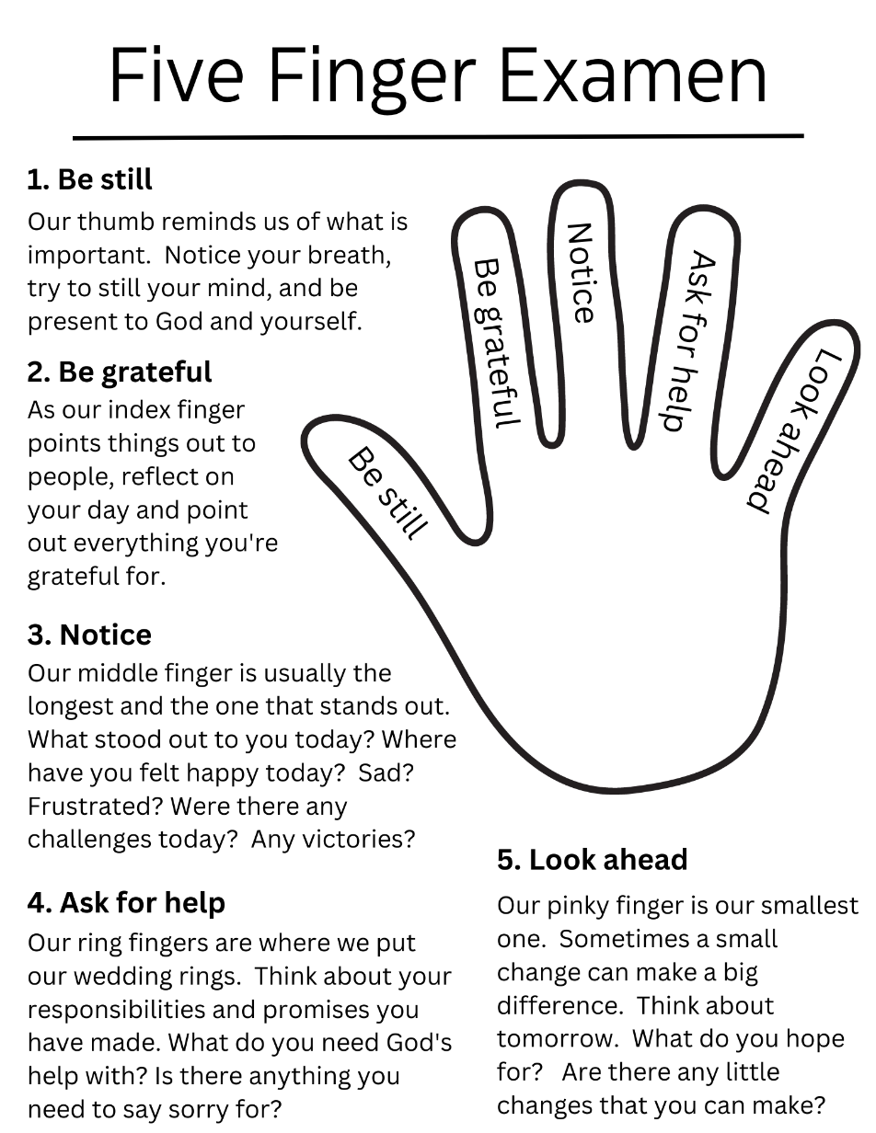

Make brief notes in a notebook or Journal. A word or two, a short paragraph at the most. And date it so you can review. So that you don’t let the words of God fall to the ground and forget them (and thus have to learn the same lesson all over again).

I want to end with a quote from a man who has provided most of the substance for all of these Lenten sessions, Father Richard J Hauser SJ who once wrote, in a passage entitled ‘One life in Christ’:

The goal of the spiritual life is to allow the Spirit of Christ to influence all our activity, prayer as well as service. Our role in this process is to provide conditions in our lives to enable us to live in tune with his Spirit. Our effort is not a self-conscious striving to fill ourselves with important Christian virtues; it is more getting out of the way and allowing his spirit to transform all our activities. Christ will do the rest. His Spirit has joined ours and will never abandon us. Gradually, we become more and more sensitive to the movements of this of Christ spirit in our own hearts; simultaneously we grow in sensitivity to the movement of his spirit in others. Subtly our vision of the world changes. We begin seeing everything in relationship to Christ and the Father, and so we carry on a continual dialogue with them. Without really trying, we find ourselves for fulfilling Paul’s injunction to the Ephesians to “Pray always.”

May this be our experience too. Amen.